**E-Commerce Application**

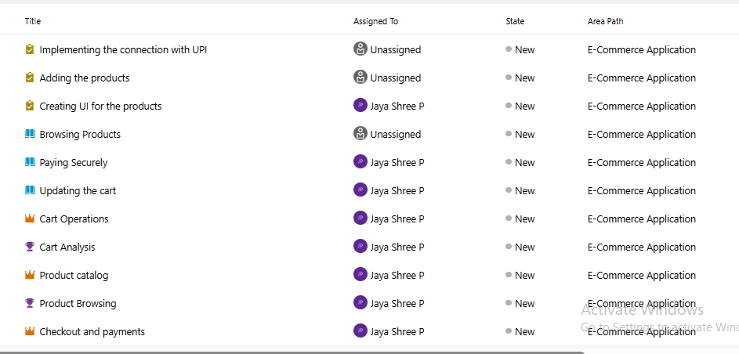

**Epic:**

* A large body of work that can be broken down into smaller chunks (Features, User Stories, and Tasks).
* It represents a high-level business goal or capability rather than a specific function.
* Epics are usually broad, long-term initiatives that may span multiple sprints or even releases**.**

Here I have given breakdown of epic , its feature, Its userstory, its task

I have also attached the screenshots at the end

**Epic 1: Product Catalog**

**Feature: Product Browsing**

* **User Story:** As a shopper, I want to browse products so that I can find items to purchase.
  + **Tasks:**
    - Design product schema (Database)
    - Create API to fetch product details
    - Build product listing UI
    - Write unit tests for product retrieval

**Feature: Search & Filtering**

* **User Story:** As a shopper, I want to search and filter products so that I can quickly find what I need.
  + **Tasks:**
    - Implement search API
    - Build filtering options (price, category, brand)
    - Optimize queries for performance
    - Test search & filter functionality

**Epic 2: Shopping Cart**

**Feature: Cart Operations**

* **User Story:** As a shopper, I want to add or update items in my cart so that I can review them later.
  + **Tasks:**
    - Design cart schema (Database)
    - Create API for add/update/remove cart items
    - Build cart UI (view summary)
    - Write unit tests for cart operations

**Feature: Cart Analytics**

* **User Story:** As a business, I want to track abandoned carts so that I can improve conversions.
  + **Tasks:**
    - Capture cart events (add/remove)
    - Store abandoned cart logs
    - Generate cart abandonment reports
    - Validate analytics accuracy

**Epic 3: Checkout & Payments**

**Feature: Payment Processing**

* **User Story:** As a shopper, I want to securely pay for my order so that my purchase is successful.
  + **Tasks:**
    - Define payment schema
    - Integrate with payment gateway API
    - Implement fraud checks
    - Monitor payment transactions

**Feature: Invoice & Receipts**

* **User Story:** As a shopper, I want to receive an invoice so that I have proof of my purchase.
  + **Tasks:**
    - Build ETL pipeline to generate invoices (PDF/JSON)
    - Store invoices in cloud storage
    - Create invoice retrieval API
    - Test invoice generation

**Epic 4: Order Management**

**Feature: Order Tracking**

* **User Story:** As a shopper, I want to track my order so that I know its delivery status.
  + **Tasks:**
    - Design order schema
    - Build real-time order update pipeline
    - Create order tracking API
    - Develop order status dashboard

**Feature: Order Analytics**

* **User Story:** As a business, I want sales reports so that I can analyze performance.
  + **Tasks:**
    - Build ETL pipeline for daily orders
    - Aggregate sales by region/product
    - Create Power BI dashboards
    - Automate data refresh

**Epic 5: User Profile & Security**

**Feature: Profile Management**

* **User Story:** As a shopper, I want to manage my profile so that I can update my personal details.
  + **Tasks:**
    - Create user profile schema
    - Build profile API
    - Implement update functionality
    - Test profile management

**Feature: Security & Audit**

* **User Story:** As a system admin, I want to monitor user activity so that I can detect suspicious behavior.
  + **Tasks:**
    - Build login activity logging
    - Store logs in secure storage
    - Monitor suspicious activity
    - Automate audit reports

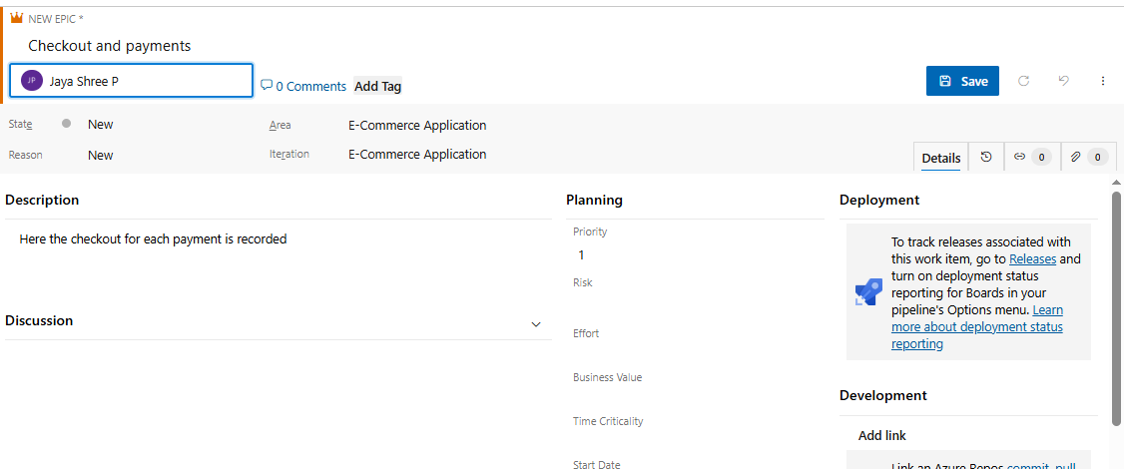

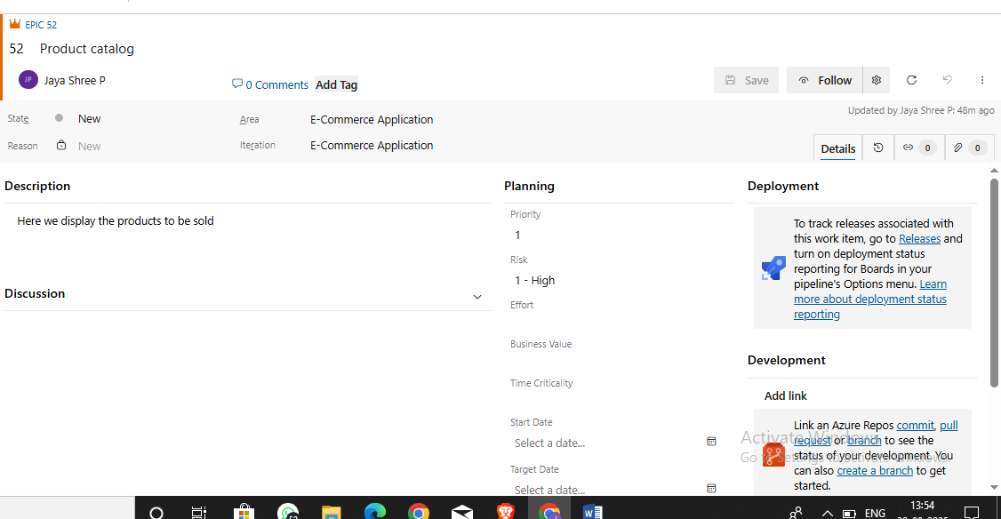

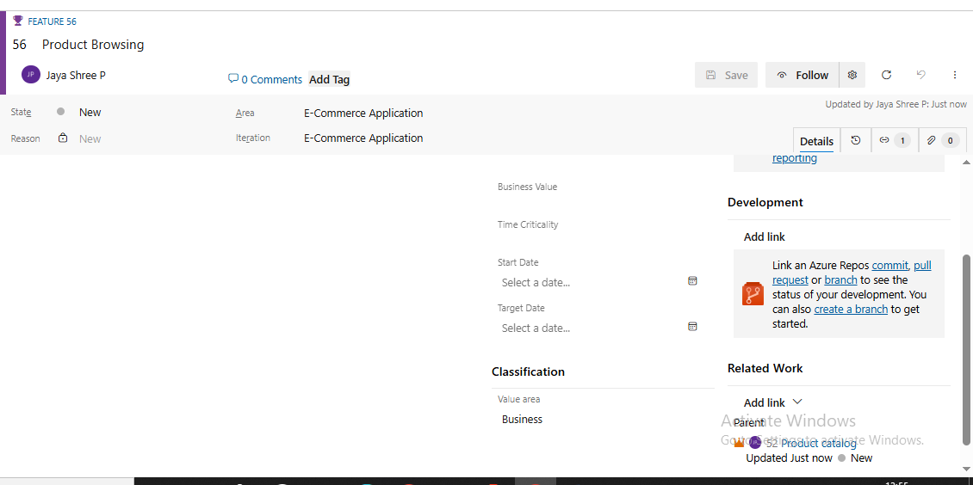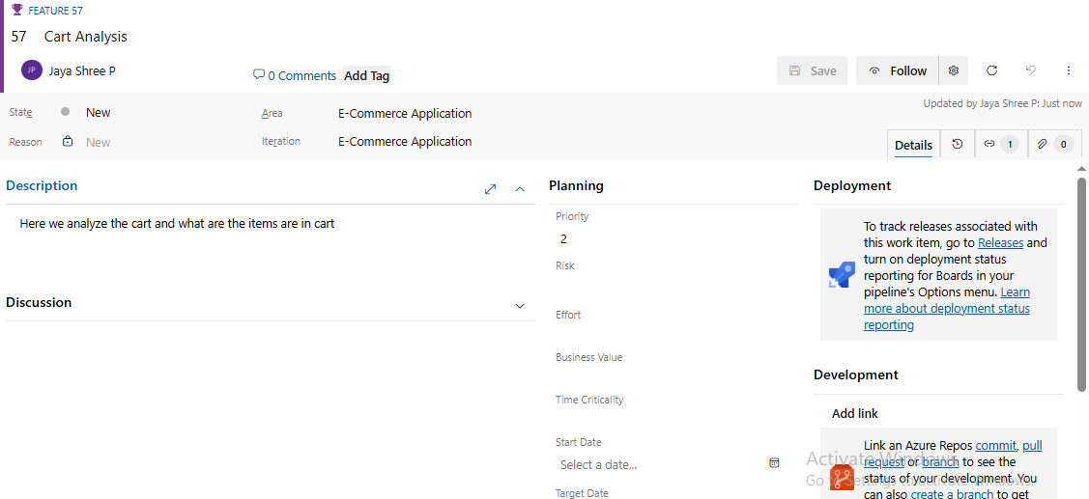

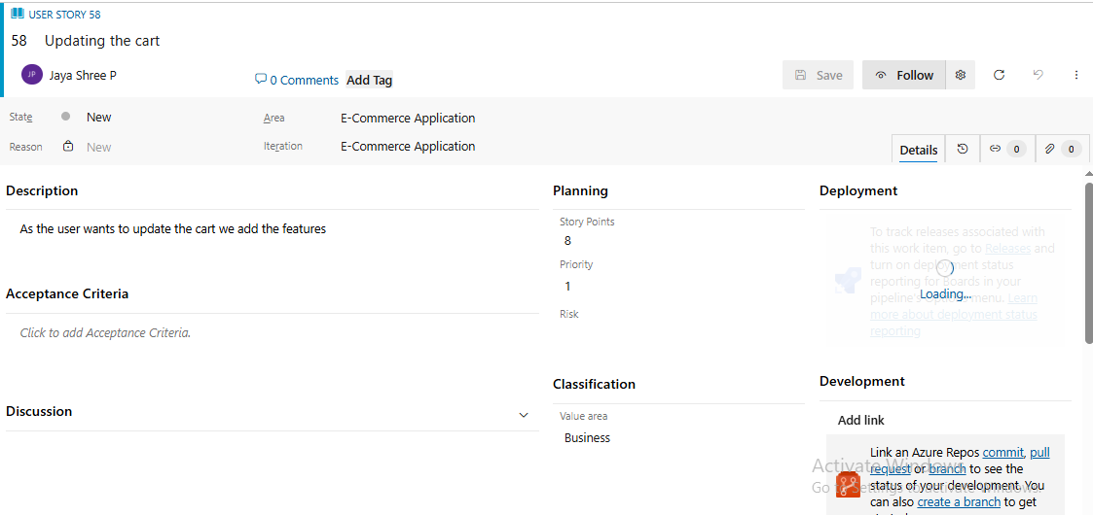

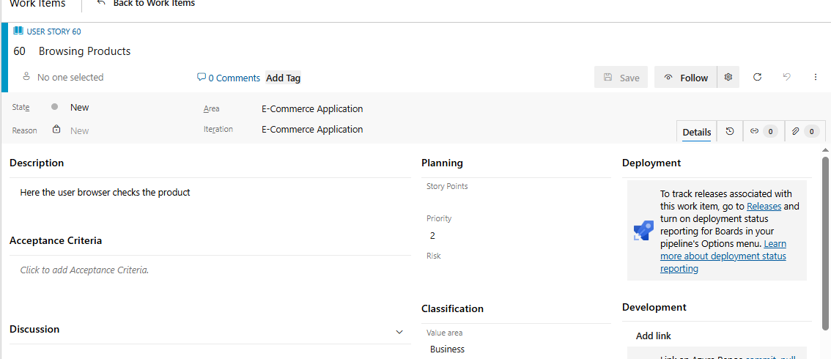

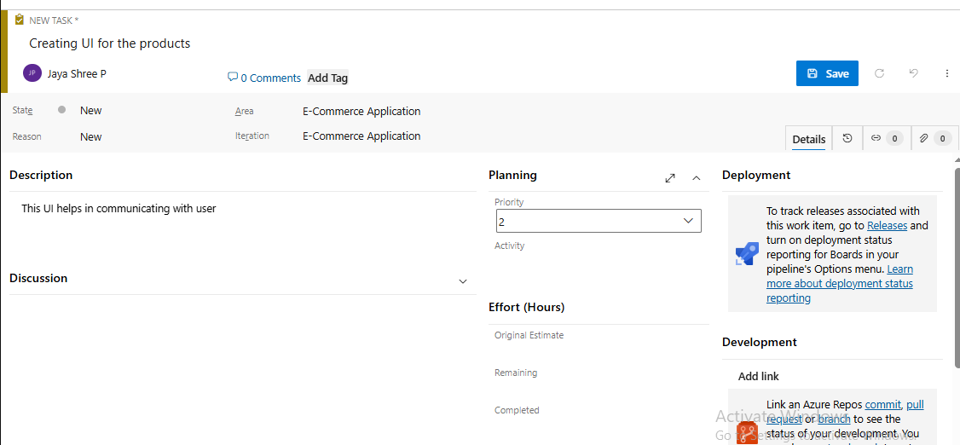

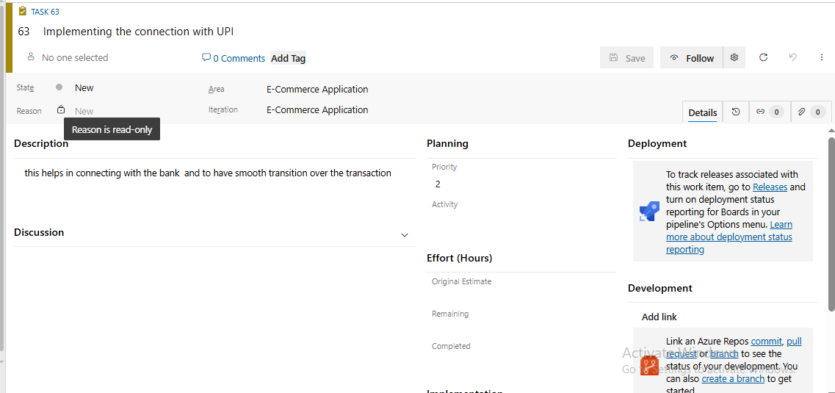

**CI/CD pipeline:**

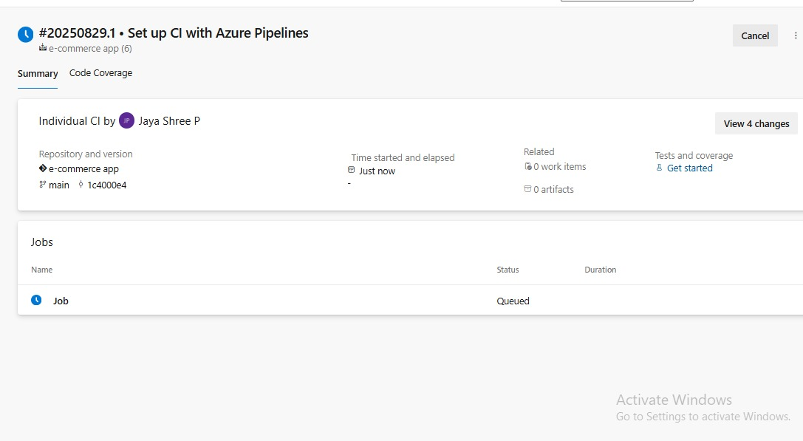

**Steps:**

